**Object-Oriented Application Development**

**Practical 1**

**Part A**

**Step 1**

1. Create a folder on the Desktop to store your programs. Name the folder Practical1.

**Step 2**

1. Start Visual Studio 2015.
2. Start Page displays. Close Start Page.
3. Create a new project:
   1. File > New > Project.
   2. The New Project dialog displays.

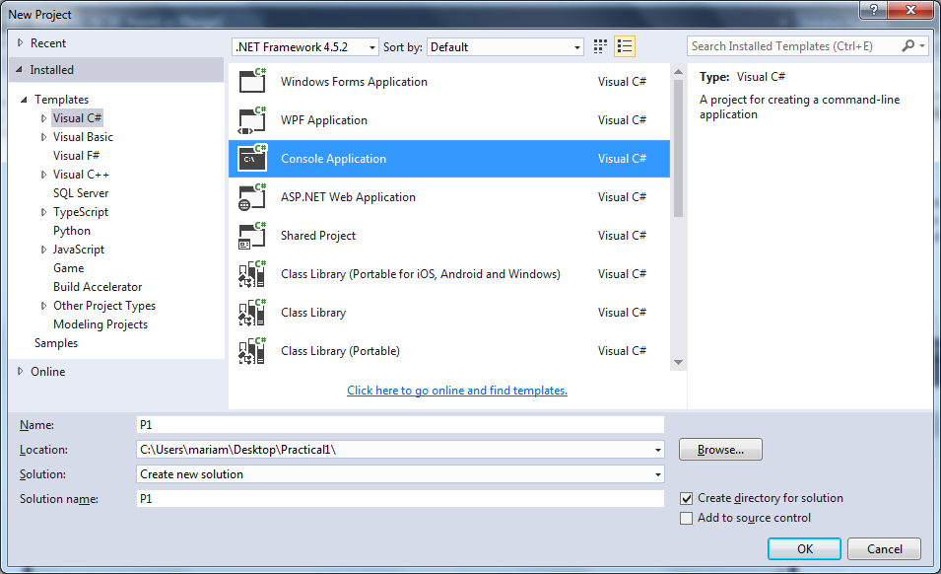

* 1. Select Visual **C#** for Templates and then select **Console Application**.
  2. Enter **P1** for project name. Select **Practical1** folder on the Desktop for the project location. Click OK to create the project.

1. The Solution Explorer window shows the newly created solution with one project.
2. The Code Editor window opens and contains some code provided by the IDE.

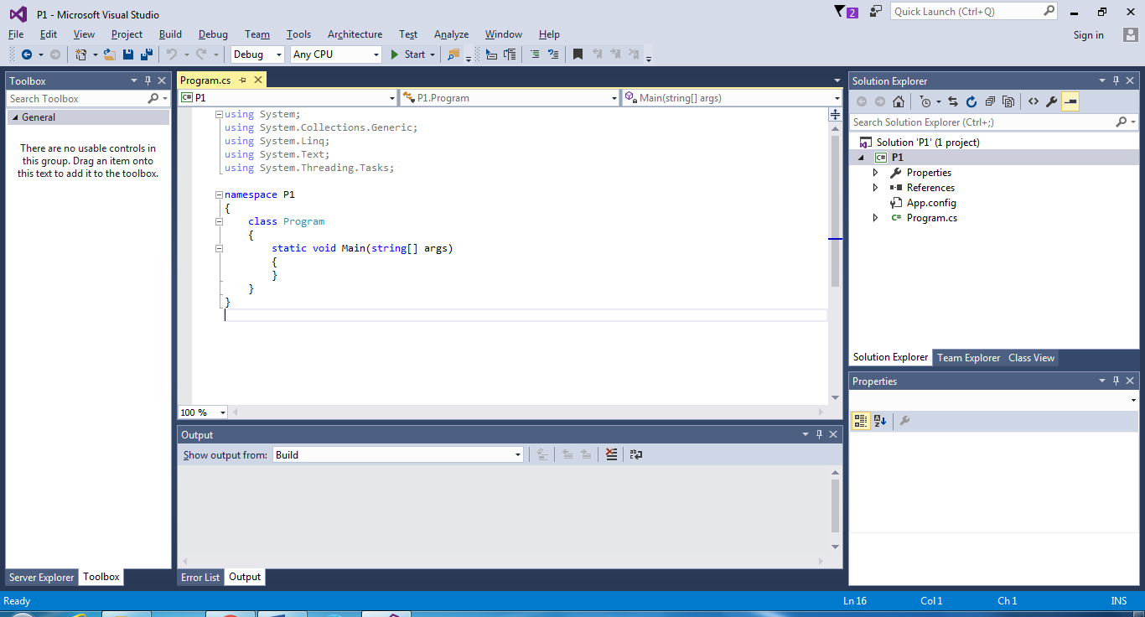

Note the following:

* The program name has extension ‘.cs’ for C#.
* The using directives are automatically added. Only ‘using System;’ is actually needed. The rest are optional for now.
* The Main method has a parameter named args and of type string[]. This parameter is optional.

1. Change the name of the program in the project:
   1. Click Program.cs in the Solution Explorer window.
   2. The Properties window opens.
   3. Change the File Name property to FirstProgram.cs.
   4. A dialog displays to confirm the change. Click Yes. Note the class name is changed as well.

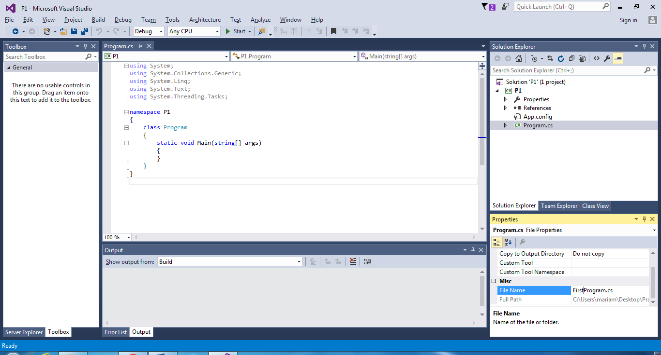

1. Type in the lines for the Main() method so that the program lines are as follows:

|  |
| --- |
| using System;  namespace P1  {  class FirstProgram  {  static void Main()  {  // test WriteLine() method  Console.WriteLine("Welcome to C# Programming!");  }  }  } |

1. Save the program.

File>Save FirstProgram.cs (or click the Save icon in the toolbar).

1. If there are any errors, the errors appear in the Error List window. If the window is not visible, select View>Error List.
2. Run the program.

Debug>Start Without Debugging or press Ctrl+F5.

1. A console window opens with the program output.

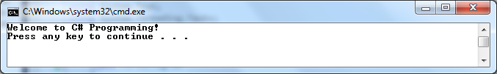

1. Press any key to close the window.

**Part B**

1. Add a new program file to the project and run the program:
   1. In the Solution Explorer, right-click the project named P1.
   2. Add a new program:

Add>New Item or click the Add New Item icon in the Toolbar.

* 1. Make sure **Class** option is selected. Type the name **Message1.cs** and click Add.

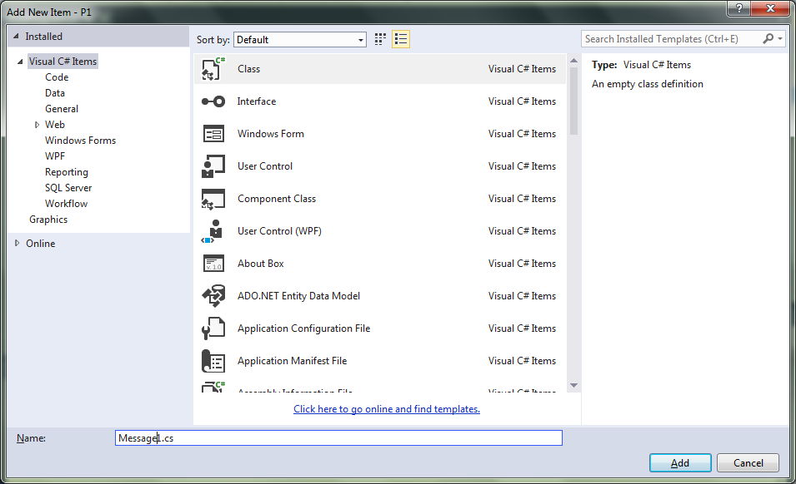

* 1. Type in the lines for the Main() method so that the program lines are as follows:

|  |
| --- |
| using System;  namespace P1  {  class Message1  {  static void Main()  {  // test Write() and WriteLine() methods  Console.Write("Welcome to ");  Console.WriteLine("C# Programming!");  Console.WriteLine("The End");  }  }  } |

* 1. Click FirstProgram.cs in the Solution Explorer window.
  2. Select **None** for the **Build Action** property.
  3. Click Message1.cs in the Solution Explorer window.
  4. Make sure **Compile** is selected for the **Build Action** property.
  5. Run the program and note the output: Debug>Start Without Debugging.

1. Run the following program that **formats output**:

|  |
| --- |
| using System;  namespace P1  {  class Message2  {  static void Main(string[] args)  {  // test formatting output  Console.WriteLine("number: {0} string: {1}",  123, "abc");  Console.WriteLine("{0}\n{1}\t{2}",  123, "abc", 45.678);  }  }  } |

1. Run the following program that **inputs integers**.

|  |
| --- |
| using System;  namespace P1  {  class Addition  {  static void Main(string[] args)  {  int number1, number2, sum;  string input;  // prompt for first number  Console.Write("Enter first integer: ");  // get first input and convert to number  input = Console.ReadLine();  number1 = Convert.ToInt32(input);  // prompt for second number  Console.Write("Enter second integer: ");  // get second input and convert to number  input = Console.ReadLine();  number2 = Convert.ToInt32(input);  // compute sum of the numbers  sum = number1 + number2;  // display the sum  Console.WriteLine("Sum is {0}", sum);  }  }  } |

**Part C**

1. Write and test a program to prompt a user to input three words on separate lines. The program then displays a blank line, followed by the words in the reverse order of input. All the words must be printed in one line. [Hint: Use 3 string variables to store the words]. Note: the output must follow the words/format shown

Sample input and output:

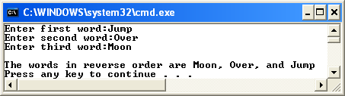

using System;

using System.Collections.Generic;

using System.Linq;

using System.Text;

using System.Threading.Tasks;

namespace P1

{

class Part_C1

{

static void Main(string[] args)

{

string input1, input2, input3;

// prompt for first word

Console.Write("Enter first word: ");

//Get first input

input1 = Console.ReadLine();

// prompt for second word

Console.Write("Enter second word: ");

// get second input

input2 = Console.ReadLine();

// prompt for third word

Console.Write("Enter third word: ");

// get third input

input3 = Console.ReadLine();

// display the in reverse order

Console.WriteLine("The words in reverse order are {2},{1}, and {0} ", input1,input2,input3);

}

}

1. Write and test a program to prompt the user to enter an integer, a floating point number, and a string on separate lines The program then displays a blank line and then the string surrounded by single quotes (i.e. ‘ and ’ ), followed by the floating point number and the integer on separate lines with some text to describe the output. Note: the output must follow the words/format shown.

Sample input and output:

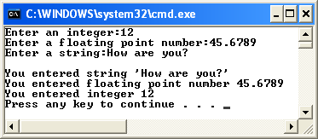

using System;

using System.Collections.Generic;

using System.Linq;

using System.Text;

using System.Threading.Tasks;

namespace P1

{

class Part_C2

{ static void Main(string[] args)

{

int input1;

double input2;

string input, input3;

// prompt for first number

Console.Write("Enter an integer: ");

input = Console.ReadLine();

input1 = Convert.ToInt32(input);

// prompt for second number

Console.Write("Enter floating point: ");

// get second input

input = Console.ReadLine();

input2 = Convert.ToDouble(input);

// prompt for third number

Console.Write("Enter string: ");

// get third input

input3 = Console.ReadLine();

// display the in reverse order

Console.WriteLine("stings, f.point and integer are {0},{1},{2} ", input1,input2,input3);

}

}

}

1. Write an application the find the sum of numbers entered by the user. The application first asks the user how many numbers he or she will enter, and then, uses a loop to input the numbers one by one.

static void Main(string[] args)

{

string numberTime;

int intNumberTime, intNumber, totalNumber = 0;

Console.Write("How many number you would like to find?: ");

numberTime = Console.ReadLine();

intNumberTime = Convert.ToInt32(numberTime);

Console.WriteLine("");

for (var counter = 1; counter <= intNumberTime; counter++)

{

Console.Write("Enter the Number " + counter + ": ");

string tempNumber = Console.ReadLine();

intNumber = Convert.ToInt32(tempNumber);

totalNumber += intNumber;

}

Console.WriteLine("");

Console.WriteLine("The sum is " + totalNumber);

1. Write an application that enables a user to enter a student’s name and three test scores and displays the average score and grade. The application should determine the student’s average score and grade according to the table below and print the student’s name, average, and grade.

|  |  |
| --- | --- |
| **Average Score** | **Grade** |
| 75 or higher | A |
| 60 to 74 | B |
| 50 to 59 | C |
| Below 50 | F |

The application should allow the user to repeat for any number of students.

public class Student

{

// instance variables

private string name;

private double score1;

private double score2;

private double score3;

// properties with get member only

public string Name

{

get { return name; }

}

public double Score1

{

get { return score1; }

}

public double Score2

{

get { return score2; }

}

public double Score3

{

get { return score3; }

}

// constructor with 3 parameters

public Student(string aName, double aScore1, double aScore2, double aScore3)

{

name = aName;

score1 = aScore1;

score2 = aScore2;

score3 = aScore3;

}

// instance method

public double ComputeAverage()

{

// local variable

double average;

average = (score1 + score2 + score3) / 3.0;

// note: call static method Ceiling() of Math class

return Math.Ceiling(average);

}

}

public class TEST

{

public static void Main()

{

string aname,i1, i2, i3;

double s1, s2, s3;

Console.WriteLine("Enter Name:");

aname = Console.ReadLine();

Console.WriteLine("Enter Score 1:");

i1 = Console.ReadLine();

s1 = Convert.ToDouble(i1);

Console.WriteLine("Enter Score 2:");

i2 = Console.ReadLine();

s2 = Convert.ToDouble(i2);

Console.WriteLine("Enter Score 3:");

i3 = Console.ReadLine();

s3 = Convert.ToDouble(i3);

Student lol = new Student(aname, s1, s2, s3);

Console.WriteLine("Name: {0}", lol.Name);

Console.WriteLine("Average Score: {0}", lol.ComputeAverage());

if (lol.ComputeAverage() >= 75)

{

Console.WriteLine("Grade A;");

}

else if (lol.ComputeAverage() >= 60)

{

Console.WriteLine("Grade B;");

}

else if (lol.ComputeAverage() >= 50)

{

Console.WriteLine("Grade C;");

}

else if (lol.ComputeAverage() >= 0)

{

Console.WriteLine("Grade F;");

}

else Console.WriteLine("Invalid");

}

}